Hotel Management System Report

Content

- Pseudocode-----------------------------------------------------1
- Flowchart-------------------------------------------------------2
- C++ code-------------------------------------------------------3

1-Pseudocode
1. Enumerations:
• Room Type: Defines three types of rooms - Single, Double, and Suite.
• Payment Method: Defines two payment methods - Cash and Visa.
2. Customer Structure:
• Stores various details about a hotel customer, including personal information, contact details, booking specifics, payment status, and method.
3. Node Class:
• Represents a node in a linked list.
• Contains a Customer data member and a pointer to the next node.
4. LinkedList Class:
• Manages a linked list of customers.
• Provides methods to insert, remove, search, and access customer information.
5. Hotel Class:
• Represents the hotel management system.
• Functions include booking rooms, vacating rooms, printing occupancy status, printing customer details, and printing room prices.
• Utilizes arrays of linked lists to manage room occupancy and a linked list for the waitlist.
• Implements methods to calculate total costs, find empty rooms, and perform room management operations.
6. Main Function:
• Provides a user interface for interacting with the hotel system.
• Presents options to book rooms, vacate rooms, print occupancy status, search by customer name, view room prices, and exit the program.
• Accepts user input to execute the desired functionality
2-Flowchart

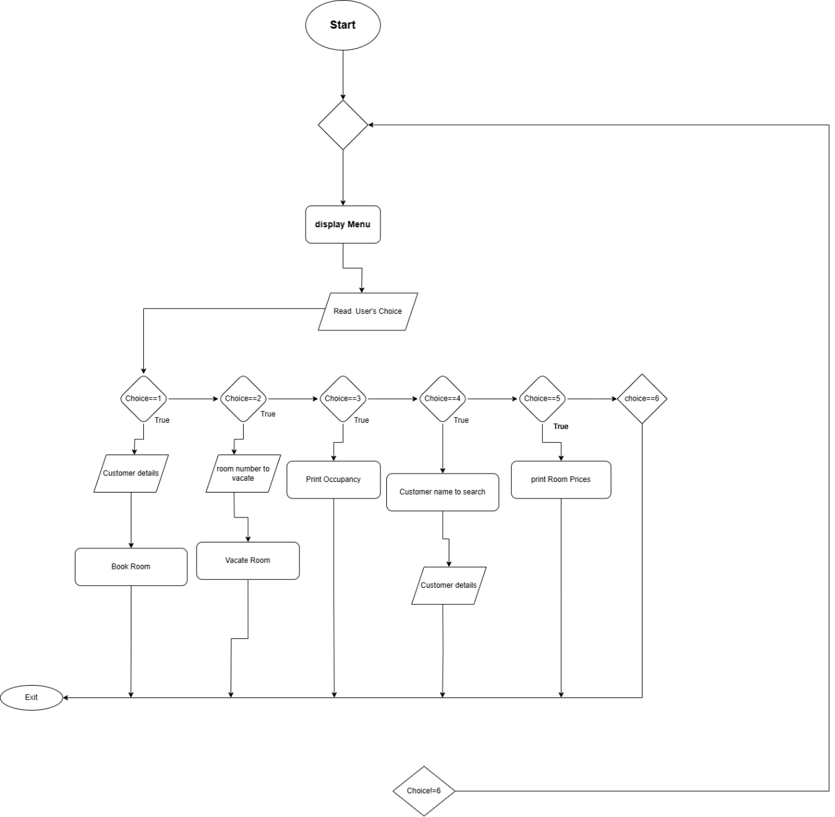
3-code
#include <iostream>
#include <string>
#include <stdexcept>

using namespace std;

enum class RoomType { Single, Double, Suite };
enum class PaymentMethod { Cash, Visa };

struct Customer {
string name;
int age;
string nationality;
string nationalID;
string email;
string phoneNumber;
int numAdults;
int numChildren;
int stayDays;
RoomType roomType;
int roomNumber;
bool paid;
PaymentMethod paymentMethod;

Customer(const string& n, int a, const string& nat, const string& id, const string& mail,
const string& phone, int adults, int children, int days, RoomType type, int number, PaymentMethod payment)
: name(n), age(a), nationality(nat), nationalID(id), email(mail), phoneNumber(phone),
numAdults(adults), numChildren(children), stayDays(days), roomType(type),
roomNumber(number),
paid(false), paymentMethod(payment) {}
};

class Node {
public:
Customer data;
Node* next;

Node(const Customer& customer) : data(customer), next(nullptr) {}
};

class LinkedList {
private:
Node* head;

public:
LinkedList() : head(nullptr) {}

~LinkedList() {
while (head != nullptr) {
Node* temp = head;
head = head->next;
delete temp;
}
}
void insert(const Customer& customer) {
Node* newNode = new Node(customer);
newNode->next = head;
head = newNode;
}

Customer remove() {
if (isEmpty()) {
throw runtime_error("List is empty");
}
Node* temp = head;
Customer data = temp->data;
head = head->next;
delete temp;
return data;
}

bool isEmpty() const {
return head == nullptr;
}

bool search(const Customer& customer) const {
Node* current = head;
while (current != nullptr) {
if (current->data.name == customer.name && current->data.roomNumber == customer.roomNumber) {
return true;
}
current = current->next;
}
return false;
}

Customer* searchByName(const string& name) const {
Node* current = head;
while (current != nullptr) {
if (current->data.name == name) {
return &current->data;
}
current = current->next;
}
return nullptr;
}

Customer* searchByRoomNumber(int roomNumber) const {
Node* current = head;
while (current != nullptr) {
if (current->data.roomNumber == roomNumber) {
return &current->data;
}
current = current->next;
}
return nullptr;
}

Node* getHead() const {
return head;
}
};

class Hotel {
private:
LinkedList rooms[5];
LinkedList waitlist;
double roomPrices[3] = { 100.0, 150.0, 250.0 }; // Room prices for Single, Double, and Suite respectively
double childDiscountRate = 0.1; // 10% discount for each child in the room

double calculateTotalCost(const Customer& customer) const {
double basePrice = roomPrices[static_cast<int>(customer.roomType)];
double adultCost = customer.stayDays * basePrice;
double childCost = customer.numChildren * (basePrice * childDiscountRate); // Calculate child discount

double totalCost = adultCost - childCost;
return totalCost;
}

int findEmptyRoom() const {
for (int i = 0; i < 3; ++i) {
if (rooms[i].isEmpty()) {
return i;
}
}
return -1;
}

public:
void bookRoom(const Customer& customer) {
int emptyRoomIndex = findEmptyRoom();
if (emptyRoomIndex != -1) {
// Empty room available, book it
double totalCost = calculateTotalCost(customer);
Customer newCustomer = customer;
newCustomer.roomNumber = emptyRoomIndex + 1; // Assign room number

// Prompt for payment method
cout << "Choose payment method (0 for Cash, 1 for Visa): ";
int paymentChoice;
cin >> paymentChoice;

switch (paymentChoice) {
case 0:
newCustomer.paymentMethod = PaymentMethod::Cash;
break;
case 1:
newCustomer.paymentMethod = PaymentMethod::Visa;
break;
default:
cout << "Invalid payment method choice. Defaulting to Cash." << endl;
newCustomer.paymentMethod = PaymentMethod::Cash;
break;
}

rooms[emptyRoomIndex].insert(newCustomer);

cout << "Room " << newCustomer.roomNumber << " booked for " << newCustomer.name << " - Type: ";
switch (newCustomer.roomType) {
case RoomType::Single:
cout << "Single";
break;
case RoomType::Double:
cout << "Double";
break;
case RoomType::Suite:
cout << "Suite";
break;
}
cout << ". Payment method: ";
switch (newCustomer.paymentMethod) {
case PaymentMethod::Cash:
cout << "Cash";
break;
case PaymentMethod::Visa:
cout << "Visa";
break;
}
cout << ". Total Cost: $" << totalCost << endl;
}
else {
// No empty rooms, add to waitlist
waitlist.insert(customer);
cout << "All rooms are occupied. Added " << customer.name << " to the waitlist." << endl;
}
}

void vacateRoom(int roomNumber) {
for (int i = 0; i < 3; ++i) {
Customer* customer = rooms[i].searchByRoomNumber(roomNumber);
if (customer != nullptr) {
cout << "Customer " << customer->name << " has vacated Room " << roomNumber << endl;
rooms[i].remove();
break;
}
}
}

void printOccupancy() const {
cout << "Occupancy Status:\n";
for (int i = 0; i < 3; ++i) {
cout << "Room " << i + 1 << ": ";
if (!rooms[i].isEmpty()) {
cout << "Booked\n";
}
else {
cout << "Available\n";
}
}
}

void printCustomerDetails(const string& name) const {
bool found = false;

// Search in the rooms
for (int i = 0; i < 3; ++i) {
Customer* customer = rooms[i].searchByName(name);
if (customer != nullptr) {
int remainingDays = customer->stayDays;
cout << "Customer: " << customer->name << ", Room Number: " << customer->roomNumber
<< ", Remaining Days: " << remainingDays ;
cout << ", Payment Method: ";
switch (customer->paymentMethod) {
case PaymentMethod::Cash:
cout << "Cash";
break;
case PaymentMethod::Visa:
cout << "Visa";
break;
}
cout << endl;
found = true;
break;
}
}

// If not found in rooms, check the waitlist
if (!found) {
Customer* customerInWaitlist = waitlist.searchByName(name);
if (customerInWaitlist != nullptr) {
cout << "Customer " << name << " is in the waitlist." << endl;
found = true;
}
}

// If still not found, display "No"
if (!found) {
cout << "Customer '" << name << "' not found. Paid: No" << endl;
}
}

void printRoomPrices() const {
cout << "Room Prices:\n";
cout << "Single Room: $" << roomPrices[static_cast<int>(RoomType::Single)] << endl;
cout << "Double Room: $" << roomPrices[static_cast<int>(RoomType::Double)] << endl;
cout << "Suite: $" << roomPrices[static_cast<int>(RoomType::Suite)] << endl;
}
};

int main() {
Hotel hotel;
int choice;
do {
cout << "1. Book Room\n2. Vacate Room\n3. Print Occupancy\n4. Search by Name\n5. Room Prices\n6. Exit\n";
cout << "Enter your choice: ";
cin >> choice;

switch (choice) {
case 1: {
// Prompt user for customer details
string name;
int age, roomTypeInt, numAdults, numChildren, stayDays;

cout << "Enter customer name: ";
cin >> name;
cout << "Enter age: ";
cin >> age;
cout << "Enter number of adults: ";
cin >> numAdults;
cout << "Enter number of children: ";
cin >> numChildren;
cout << "Enter number of stay days: ";
cin >> stayDays;
cout << "Enter room type (0 for Single, 1 for Double, 2 for Suite): ";
cin >> roomTypeInt;

RoomType roomType;
switch (roomTypeInt) {
case 0:
roomType = RoomType::Single;
break;
case 1:
roomType = RoomType::Double;
break;
case 2:
roomType = RoomType::Suite;
break;
default:
cout << "Invalid room type." << endl;
continue; // Restart loop
}

// Create the customer object
Customer newCustomer(name, age, "", "", "", "",
numAdults, numChildren, stayDays, roomType, -1, PaymentMethod::Cash); // Room number set to -1 initially

hotel.bookRoom(newCustomer);
break;
}
case 2: {
// Prompt for room number to vacate
int roomNumber;
cout << "Enter room number to vacate (1 to 3): ";
cin >> roomNumber;
hotel.vacateRoom(roomNumber);
break;
}
case 3: {
hotel.printOccupancy();
break;
}
case 4: {
// Prompt for customer name to search
string name;
cout << "Enter customer name: ";
cin >> name;
hotel.printCustomerDetails(name);
break;
}
case 5: {
hotel.printRoomPrices();
break;
}
case 6:
cout << "Exiting..." << endl;
break;
default:
cout << "Invalid choice. Please try again." << endl;
}
} while (choice != 6);

return 0;
}

